IIMT E-Talent Hunt 2K21
Organized by
IIMT Group of Colleges, Greater Noida

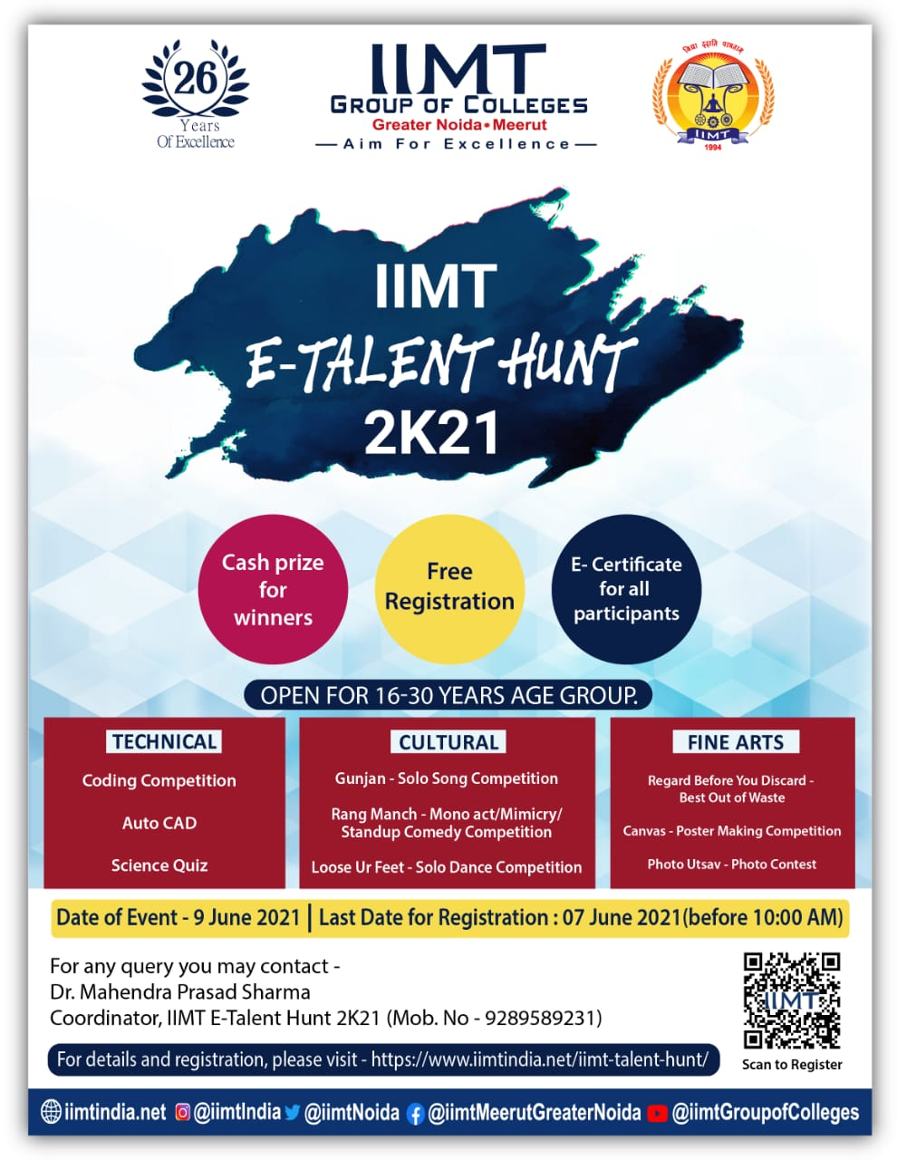

General Rules

- Entries of registered candidates will only be accepted.
- Only original/ unpublished/unreleased work will be accepted. Except Quiz, entries of all events may be submitted online before 7th June, 2021 by 10:00 a.m. through respective email id’s provided for the same.
- The events are open for 16 – 30 years age group. It’s applicable for all activities.
- Decision of Judges will be final and binding on all participants
- Judgment will be done in two rounds
  - In first round best 10 entries will be selected by the judges appointed by organizers.
  - In 2nd round selected 10 entries for each contest will be posted on Facebook/ Instagram / YouTube. The links of above social sites will be widely circulated.
  - The entries getting maximum likes in each event will be announced winners for 1st, 2nd & 3rd positions.
  - Marks allocated to participants for the various events will be based on score awarded by the jury Members (40 %) as well as like on social media like YouTube, Facebook and Instagram (60 %).
  - By summing up the result of Jury members (40 %) and social media (60 %) final winner of the event will be announced.
- The first and second runner up will be eligible for certificate of merit, and the winner will receive cash prize along with the certificate of merit.
- E - certificates will be given to all participants.
- Judgment may take 10 to 15 days after the fest.

- Technical Event Coordinator : Mr. Dinesh Yadav (9999295064)
- Fine Arts Event Coordinator : Dr. Priyanka (8595255452)
- Cultural Event Coordinator : Mr. Achal Kumar (9891466412)

IIMT E-Talent Hunt 2K21
Technical Event

Organized by
Department of Computer Science and Engineering
IIMT College of Engineering, Greater Noida

Event: Coding Competition

Rules and Guidelines:

- There will be 3 questions with time duration of 1 hour.
- Participant can solve all questions in any programming language.
- Contest will be conducted on online mode on Hackerrank, and evaluated by Hacker rank itself. If you do not have Hacker rank account, then visit https://www.Hackerrank.com.
- Link will be shared on participant’s email-id and disabled after 1 hour automatically, and no one can submit after that time duration.
- Ties will be broken by the total time for each participant’s in ascending order of time.
- In case of any unwanted activities like copying code from internet, misbehaving with other participants and organizers, getting involved in any malicious activity), participants will be disqualified with immediate effect.
- The first and second runner up will be eligible for certificate of merit, and the winner will receive cash prize along with the certificate of merit.
- Last date of registration: 07 June 2021 (before 10:00 a.m.).
Date of Event: 09 June 2021.

Note: For any information and query please contact the undersigned.

Mr. Manik Chandra Pandey Vivek Pandey
Faculty Coordinator Student Coordinator
Contact No: 8864881199 Contact No: 7258893392

E - mail: coding_gn@iimtindia.net

IIMT E-Talent Hunt 2K21
Technical Event
Organized by
Department of Civil Engineering
IIMT College of Engineering, Greater Noida

Event: Auto CAD

Rules and Guidelines:

- Limited to one entry per student.
- Time limit is one hour.
- Drawing will be provided on the spot.
- Project must be the done by student himself.
- Student must utilize standard CAD equipment.
- A complete design is required.
- The completed design must be sent in both pdf and dwg file.
- The first and second runner up will be eligible for certificate of merit, and the winner will receive cash prize along with the certificate of merit.
- Last date of registration: 07 June 2021 (before 10:00 a.m.).
Date of event: 09 June 2021.

Note: For any information and query please contact the undersigned.

Mr. Pankaj Kumar Aryan Dubey
Faculty Coordinator Student Coordinator
Contact No: 8010271339 Contact No: 9560086963

E - mail: autocad_gn@iimtindia.net

IIMT E-Talent Hunt 2K21
Technical Event
Organized by
Department of Electronics and Communication Engineering
IIMT College of Engineering, Greater Noida

Event: Science Quiz

Rules and Guidelines:

- This is an individual event.
- The quiz comprises of 60 questions and the time limit is 50 minutes.
- Each question carries one mark. No negative marking for wrong answers. Questions are of multiple choice.
- Questions will be based on General Science and Aptitude.
- You can attempt the quiz only once.
- Quiz will be taken on Google Form and it will be self-evaluated on Google Form.
- In case more than one participant get equal marks for first position, the winner will be decided on the basis of time taken to submit the quiz.
- Time of quiz will be shared on your email ID a day before the event.
- The first and second runner up will be eligible for certificate of merit, and the winner will receive cash prize along with the certificate of merit.
- Last date of registration: 07 June 2021 (before 10:00 a.m.).
Date of event: 09 June 2021.

Note: For any information and query please contact the undersigned.

Dr. Govind Patel Vaishnavi Gupta
Faculty Coordinator Student Coordinator
Contact No: 7683024738 Contact No: 9871667853

E - mail: sciencequiz_gn@iimtindia.net

IIMT E-Talent Hunt 2K21
Cultural Event
Organized by
IIMT College of Polytechnic, Greater Noida

Event: Gunjan - Solo Song Competition

Rules and Guidelines:

- Video of maximum 2 minutes to be sent through email id: gunjan_gn@iimtindia.net
- A Solo performance video with or without background track is allowed.
- The first and second runner up will be eligible for certificate of merit, and the winner will receive cash prize along with the certificate of merit.
- Last date of registration: 07 June 2021 (before 10:00 a.m.).
Date of event: 09 June 2021.

Note: For any information and query please contact the undersigned.

Mr. Rajiv Ranjan Singh Ayush Choubey
Faculty Coordinator Student Coordinator
Contact No: 7053693130 Contact No: 9973539090

Event: Rang Manch – Mono Act / Mimicry/ Standup Comedy Competition

Rules and Guidelines:

- A solo performance video of maximum 2 minutes to be sent through email id: rang.manch_gn@iimtindia.net
- Unreleased/unpublished will only be entertained.
- The first and second runner up will be eligible for certificate of merit, and the winner will receive cash prize along with the certificate of merit.
- Last date of registration: 07 June 2021 (before 10:00 a.m.).
Date of event: 09 June 2021.

Note: For any information and query please contact the undersigned.

Mr. Tribhuwan Singh Shivam Pandey
Faculty Coordinator Student Coordinator
Contact No: 9999260048 Contact No: 7007091188

IIMT E-Talent Hunt 2K21
Cultural Event
Organized by
IIMT College of Polytechnic, Greater Noida

Event: Loose Ur Feet – Solo Dance Competition

Rules and Guidelines:

- Video of Maximum 2 minutes to be sent through email id: loose.ur.feet_gn@iimtindia.net
- Only Solo Performances with or without background music will be accepted.
- The first and second runner up will be eligible for certificate of merit, and the winner will receive cash prize along with the certificate of merit.
- Last date of registration: 07 June 2021 (before 10:00 a.m.).
Date of event: 09 June 2021.

Note: For any information and query please contact the undersigned.

Dr. Tanushree Madhurendra
Faculty Coordinator Student Coordinator
Contact No: 7017453310 Contact No: 7011273877

IIMT E-Talent Hunt 2K21
Fine Arts
Organized by
IIMT College of Management, Greater Noida

Event: “Photo Utsav”: Photo Contest

Rules and Guidelines:

- Theme: Life During Covid
- Maximum of Two (2) photographs carrying the caption related to it can be submitted by the participant but only one will be selected.
- The photos must be in JPEG format.
- Photography by both camera and mobile is allowed but should be of a higher resolution (e.g. 1280 x 720 pixel).
- Photograph has to be original/unpublished and no photo editing is allowed except the Black and White format.
- Winning images and overall winners will be selected on the basis of their originality and the strength of color combination or picture appeal.
- Photos that include inappropriate offensive content, violence or environmental violence are strictly prohibited and will be immediately discarded.
- The first and second runner up will be eligible for certificate of merit and the winner will receive cash prize along with the certificate of merit.
- The decision of Judges will be final.
- Photos may be submitted to photoutsav_gn@iimtindia.net
- Last date of registration: 07 June 2021 (before 10:00 a.m.).
Date of event: 09 June 2021.

Note: For any information and query please contact the undersigned.

Dr. Vinit Utpal Riya Pundhir
Faculty Coordinator Student Coordinator
Contact No: 9911364316 Contact No: 7017434392

IIMT E-Talent Hunt 2K21
Fine Arts
Organized by
IIMT College of Pharmacy, Greater Noida

Event: “Canvas” - Poster Making Competition
Rules and Guidelines:

- Theme: We stand united during Covid
- Entries of registered candidates will only be accepted.
- Poster maybe in sketch, cartoon or painting form and has to be submitted in jpg file to canvas@iimtindia.net
- Only original/ unpublished/unreleased work on A3 or A4 sheet will be accepted.
- All posters must be related to the topic or theme of poster making competition.
- Decision of Judges will be final and binding on all participants.
- The first and second runner up will be eligible for certificate of merit and the winner will receive cash prize along with the certificate of merit.
- Last date of registration: 07 June 2021 (before 10:00 a.m.).
Date of event: 09 June 2021.

Note: For any information and query please contact the undersigned.

Mr. Alok Nath Sharma Lalit Raj
Faculty Coordinator Student Coordinator
Contact No: 9045422236 Contact No: 8789783944

IIMT E-Talent Hunt 2K21
Fine Arts
Organized by
IIMT College of Management, Greater Noida

Event: “Regard Before You Discard” - Best Out of Waste

Rules and Guidelines:

- Only waste material ( like tetra packs, bottles, newspapers, old utensils, jute material or any second hand items that otherwise would be thrown away ) should be used for making any item of utility.
- The photo of model would be rejected if not found to be a waste product or second-hand item.
- Photograph of item in jpeg/jpg format (maximum four photos from different angles) to be sent through email id: recreation_gn@iimtindia.net.
- Maximum size of each photo should not exceed 2 MB.
- Photo must carry the caption related to it.
- By participating in this competition, the contestant agrees to accept the terms and conditions of the competition.
- The first and second runner up will be eligible for certificate of merit and the winner will receive cash prize along with the certificate of merit.
- Last date of registration: 07 June 2021 (before 10:00 a.m.).
Date of event: 09 June 2021.

Note: For any information and query please contact the undersigned.

Mr. Vijay Kumar Ayushi Rajvanshi
Faculty Coordinator Student Coordinator
Contact No: 9911669936 Contact No: 9899059912

